ISL HW7

Tejaswi Ayyadapu

Student ID: 16278799

- Draw an example (of your own invention) of a partition of two-dimensional feature space that could result from recursive binary splitting. Your example should contain at least six regions. Draw a decision tree corresponding to this partition. Be sure to label all aspects of your figures, including the regions R1,R2,.. the cut points t1,t2,...
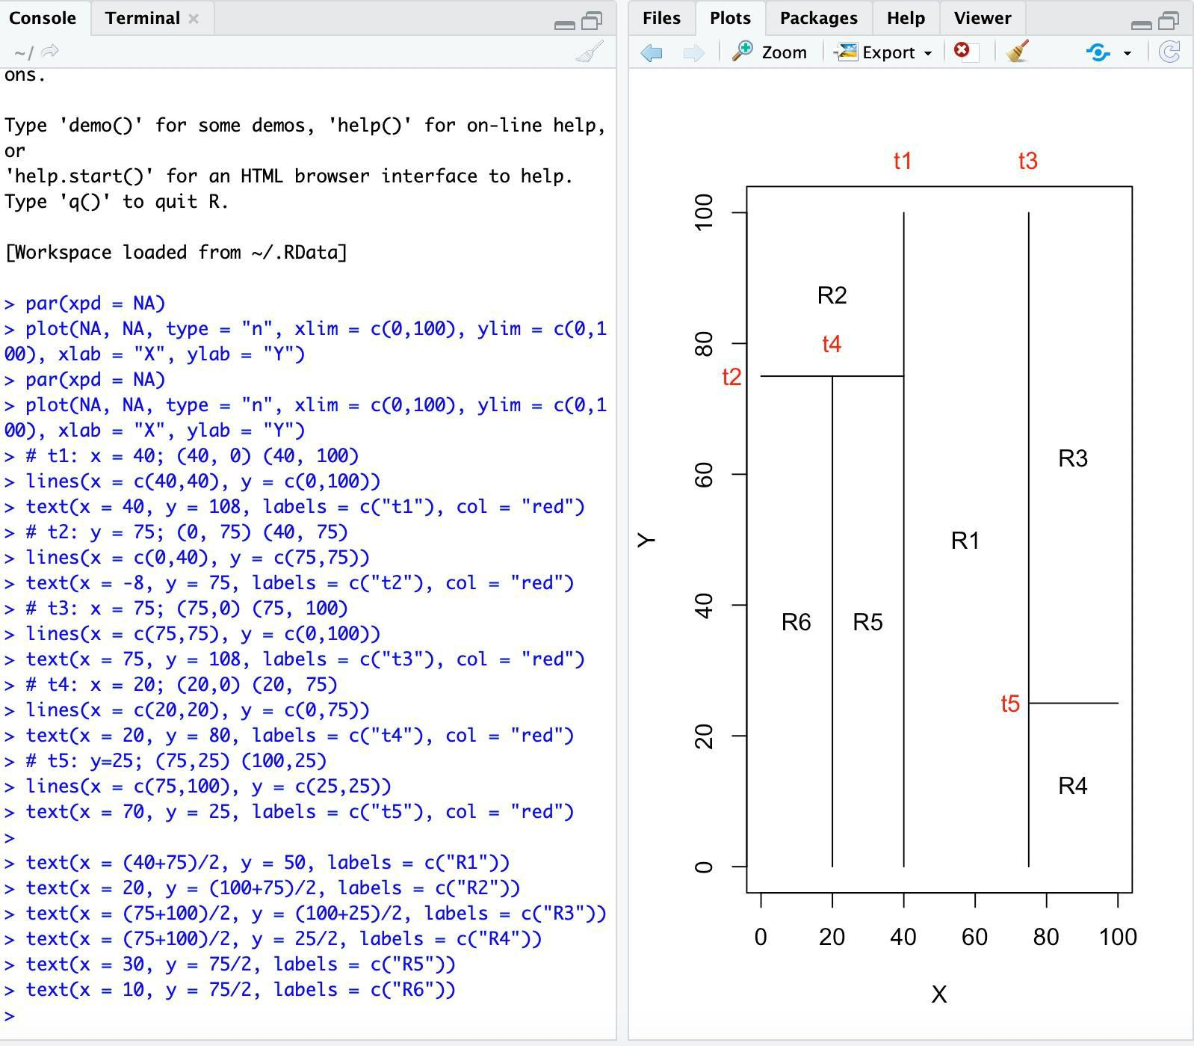
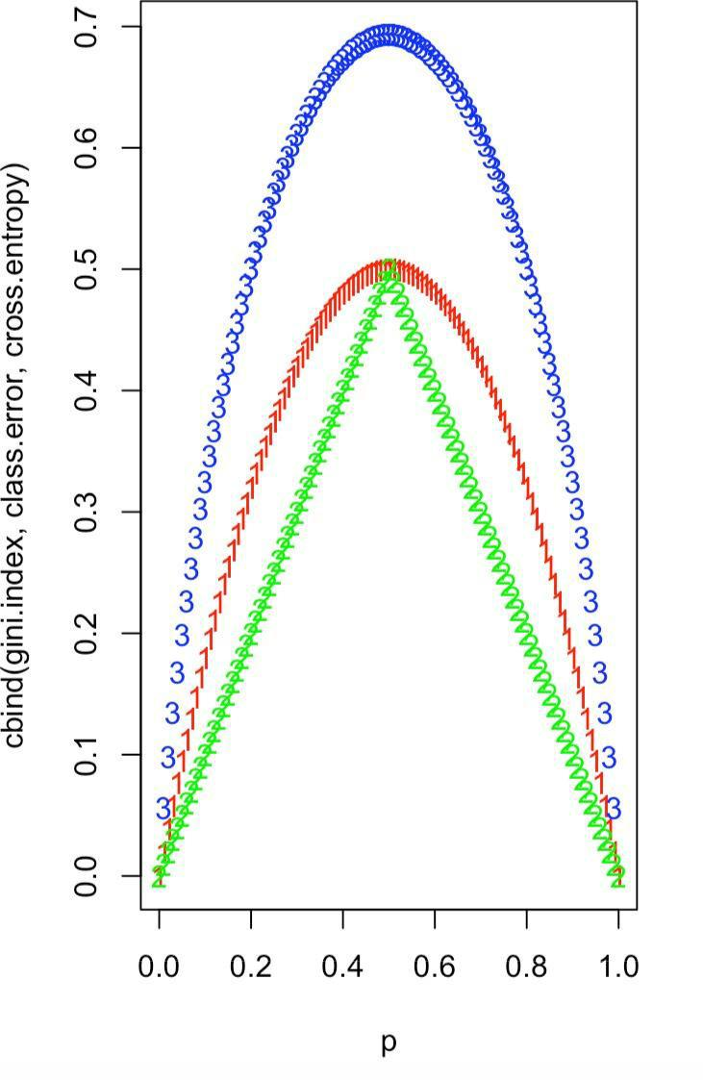
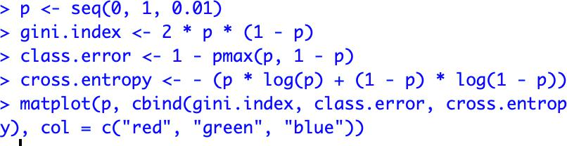
2.Consider the Gini index, classification error, and cross-entropy in a simple setting with two classes. Create a single plot that displays each of these quantities as a function of p̂m1. The x-axis should display p̂m1, ranging from 0 to 1, and the y-axis should display the value of the Gini index, classification error, and entro

3.(10 points total) Suppose we produce ten bootstrapped samples from a data set containing red and green classes. We then apply a classification tree to each bootstrapped sample and, for a specific value of X, produce 10 estimates of P(Class is Red|X):

0.1, 0.15, 0.2, 0.2, 0.55, 0.6, 0.6, 0.65, 0.7, and 0.75.

There are two common ways to combine these results together into a single class prediction. One is the majority vote approach discussed in this chapter. The second approach is to classify based on the average probability. In this example, what is the final classification under each of these two approaches?

With the majority vote approach, we classify X as Red as it is the most commonly occurring class among the 10 predictions (6 for Red vs 4 for Green). With the average probability approach, we classify X as Green as the average of the 10 probabilities is 0.45.

4.

